LAB Assignment No 6
ABDULLAH SOHAIL
70147165
Interfacing LED & Potentiometer with ESP32 and Visualizing Data on Node-RED Dashboard
LAB Description:
This lab demonstrates how IoT devices communicate with cloud-based dashboards using MQTT, enabling real-time monitoring and control.
Learning Objectives:
By the end of this lab, students will:
- Understand IoT communication using MQTT
- Interface sensors (potentiometer) with ESP32
- Control actuators (LED) remotely
- Build a web dashboard using Node-RED
- Simulate IoT systems using Wokwi
Required Tools
🔹 Hardware (Simulated)
- ESP32
- LED
- Potentiometer
🔹 Software
- Arduino IDE
- Node-RED
- MQTT Broker (e.g., HiveMQ or Mosquitto)
System Overview
Potentiometer → ESP32 → MQTT → Node-RED Dashboard (Display)
Node-RED Button → MQTT → ESP32 → LED Control
Potentiometer:
- VCC → 3.3V
- GND → GND
- OUT → GPIO 36
LED:
- Positive → GPIO 26
- Negative → GND

ESP32 Tasks
Students must:
- Connect ESP32 to WiFi
- Read potentiometer value
- Publish data to MQTT topic:
pubtopic

- Subscribe to MQTT topic:
LED
- Turn LED ON/OFF based on received message

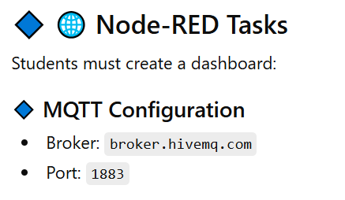
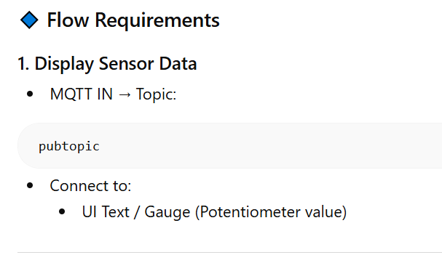
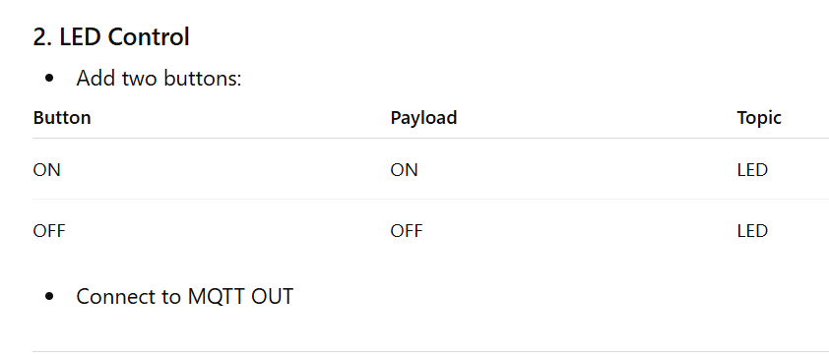

ESP32 code
#include <WiFi.h>
#include <PubSubClient.h>

// ================= WiFi =================
const char* ssid = "Wokwi-GUEST";
const char* password = "";

// ================= MQTT =================
const char* mqttServer = "broker.hivemq.com";
const int mqttPort = 1883;

// ================= Pins =================
#define ADCpin 36
#define LED 26

int ValueToSend;

// ================= Objects =================
WiFiClient espClient;
PubSubClient client(espClient);

// ================= CALLBACK =================
void callback(char* topic, byte* payload, unsigned int length) {
Serial.println();
Serial.print("Message received on topic: ");
Serial.println(topic);

String msg = "";

for (int i = 0; i < length; i++) {
msg += (char)payload[i];
}

Serial.print("Message: ");
Serial.println(msg);

if (String(topic) == "LED") {
if (msg == "ON") {
digitalWrite(LED, HIGH);
Serial.println("LED ON");
}
else if (msg == "OFF") {
digitalWrite(LED, LOW);
Serial.println("LED OFF");
}
}
}

// ================= WIFI CONNECT =================
void connectWiFi() {
Serial.print("Connecting to WiFi");
WiFi.begin(ssid, password);

while (WiFi.status() != WL_CONNECTED) {
delay(500);
Serial.print(".");
}

Serial.println("\nWiFi Connected!");
Serial.print("IP Address: ");
Serial.println(WiFi.localIP());
}

// ================= MQTT RECONNECT =================
void reconnectMQTT() {
while (!client.connected()) {
Serial.println("Connecting to MQTT...");

String clientId = "ESP32Client-";
clientId += String(random(1000));

// PUBLIC BROKER → NO USERNAME/PASSWORD
if (client.connect(clientId.c_str())) {
Serial.println("MQTT Connected!");

client.subscribe("LED"); // Subscribe topic
}
else {
Serial.print("Failed, state = ");
Serial.println(client.state());
delay(2000);
}
}
}

// ================= SETUP =================
void setup() {
Serial.begin(115200);

pinMode(LED, OUTPUT);

connectWiFi();

client.setServer(mqttServer, mqttPort);
client.setCallback(callback);
}

// ================= LOOP =================
void loop() {

if (!client.connected()) {
reconnectMQTT();
}

client.loop();

// Read ADC value
int ADC = analogRead(ADCpin);
ValueToSend = map(ADC, 0, 4095, 0, 100);

Serial.print("Pot Value (%): ");
Serial.println(ValueToSend);

// Convert to string
char payload[10];
snprintf(payload, sizeof(payload), "%d", ValueToSend);

// Publish to MQTT
client.publish("pubtopic", payload);

delay(2000);
}

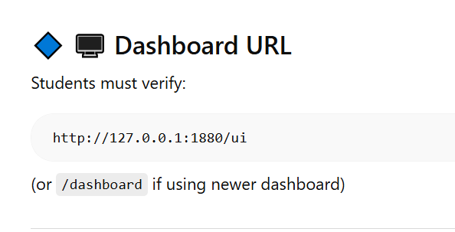
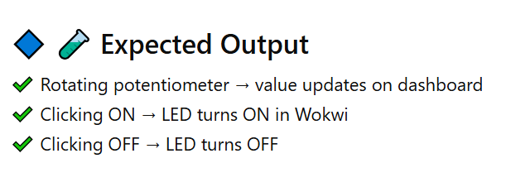
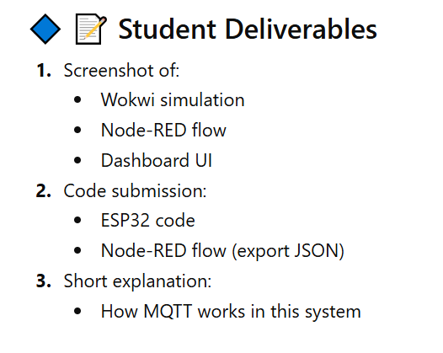
Viva Questions:
- What is MQTT and why is it used in IoT?
- Difference between publish and subscribe?
- Why do topics need to match exactly?
- What happens if broker is down?
- What is the role of Node-RED?

